Report for Mini Project 2
Bowen Yang

- Brief Introduction
This model contains a fixed pressure, temperature water source and a controlled pump which mass flow rate is fixed. The start and stop of the pump is controlled by water tank’s level value, when the water in the tank is less than 10% of its volume capacity, start the pump, when the water in the tank reaches 95%, stop the pump. What’s more, there’s a pipe model to simulate the loss for water to go up 20 m high, and a water tank which has a volume of 5 $m^{3}$ to provide water to different user profile controlled by timetables.
- System Schematic
The system schematic is as Figure 1 shows (on the next page):
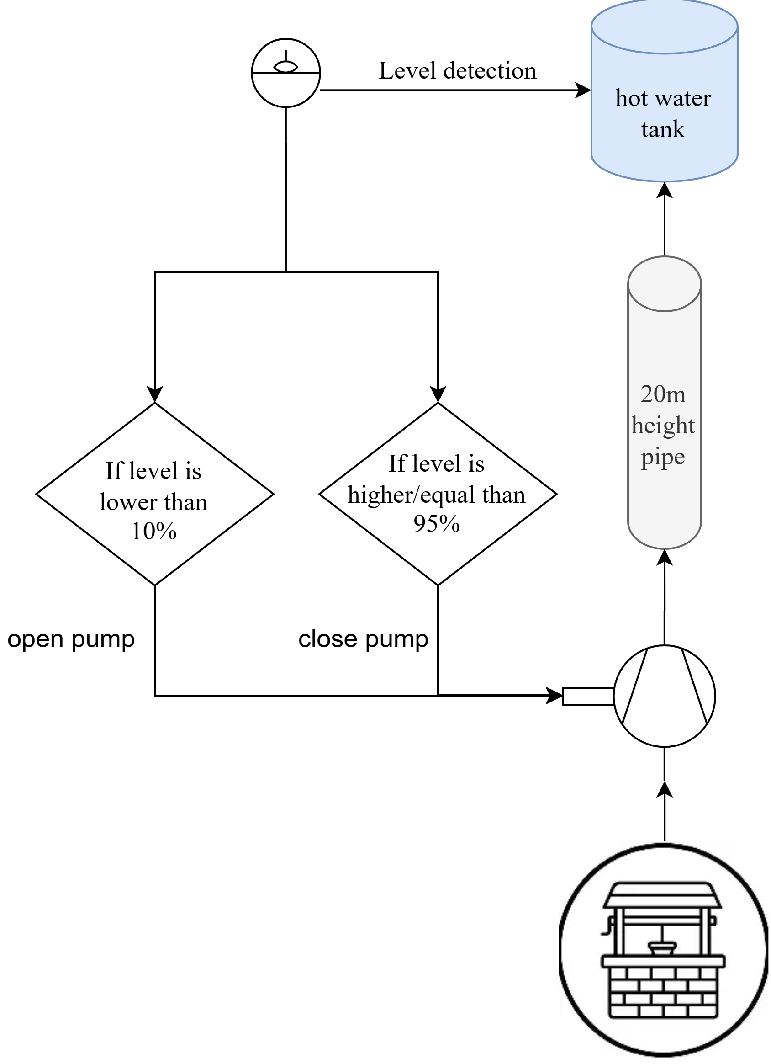
Fig. 1. System schematic of Mini Project 2

- Model Content

Table 1 Models contained in Mini Project 2

Name | Description
Boundary_PT | Boundary with prescribed pressure, temperature, composition and trace substances
ControlledPump | Centrifugal pump with ideally controlled mass flow rate
StaticPipe | Basic pipe flow model without storage of mass or energy
RealExpression | Set output signal to a time varying Real expression
Hysteresis | Transform Real to Boolean signal with Hysteresis
booleanToReal | Convert Boolean to Real signal
OpenTank | Simple tank with inlet/outlet ports
MassFlowSource_T | Ideal flow source that produces a prescribed mass flow with prescribed temperature, mass fraction and trace substances
System | System properties and default values
TimeTable | Generate a signal by linear interpolation in a table

Using These models, the pumping system of hot water tank can be created in dymola as diagram showed in figure 2.

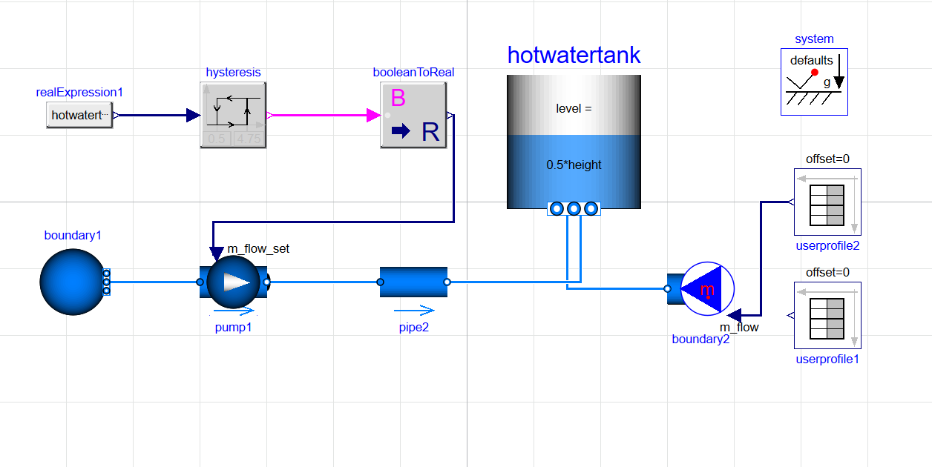
Fig. 2. System diagram of Mini Project 2 in dymola

- Assumptions
The assumption I made for Mini Project 2 contains:
- Fixed value of water pressure in the well is 1 bar, fixed value of temperature of it is 20 Celsius. The medium used in this system is Modelica.Media.Water.StandardWater
- The pump’s flow characteristics are shown in Figure 3.

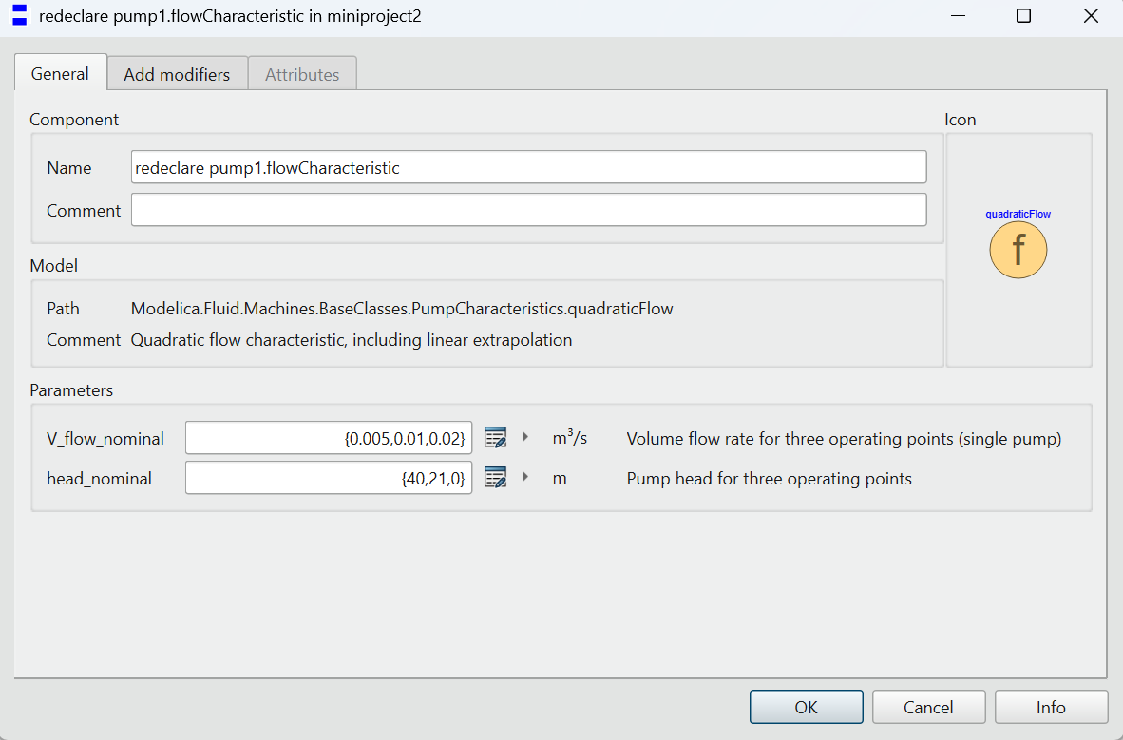
Fig. 3. Flow characteristic of pump

This set of parameters shows that when pump volume flow rate is 0.01 $m^{3}$/s, it should provide fluid the ability to overcome 21 m height of gravity. Considering the loss may apply for the water, this model set the head_nominal to 21 m, rather than 20 m.
- The pipe’s parameters are shown in Figure 4.
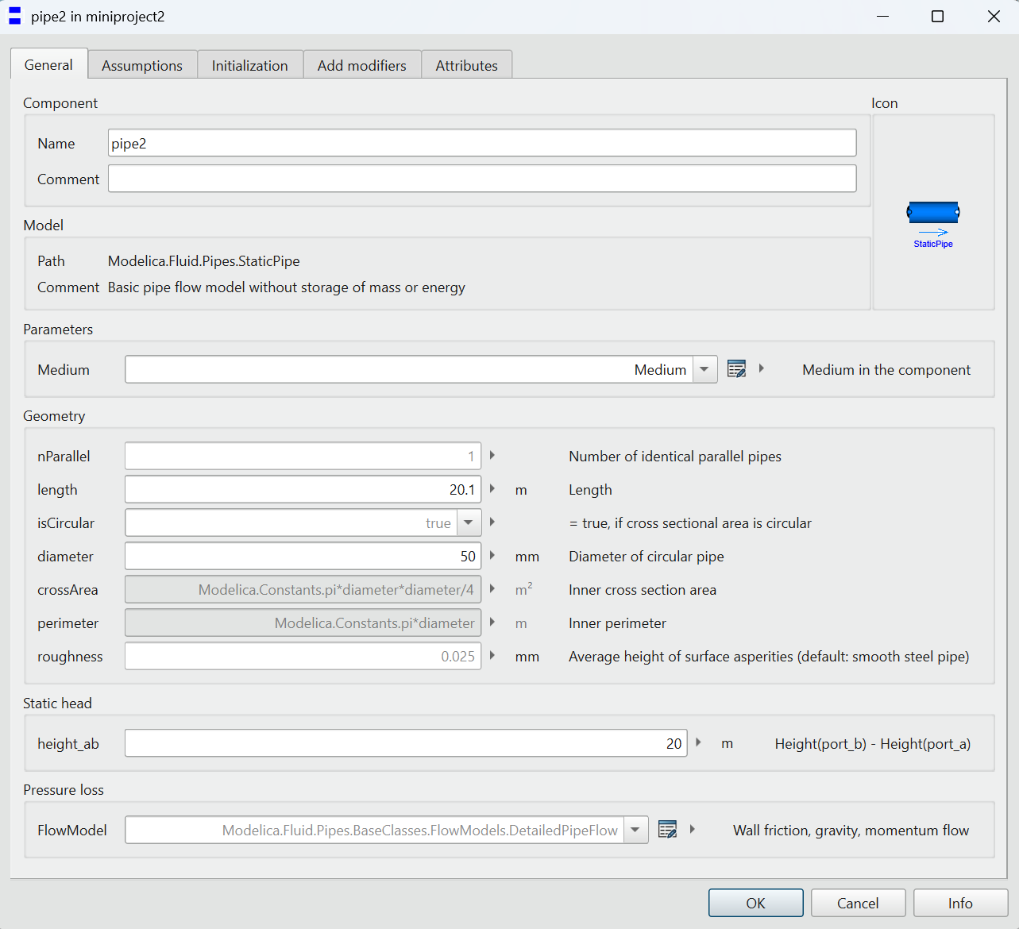
Fig. 4. Parameters of pipe

As shown in Figure 4, consider the low-mass flow this scenario maybe, this project takes 50 mm as diameter. The height here, as per request by assignment, is set to 20 m.
- The tank’s parameters are shown in Figure 5.
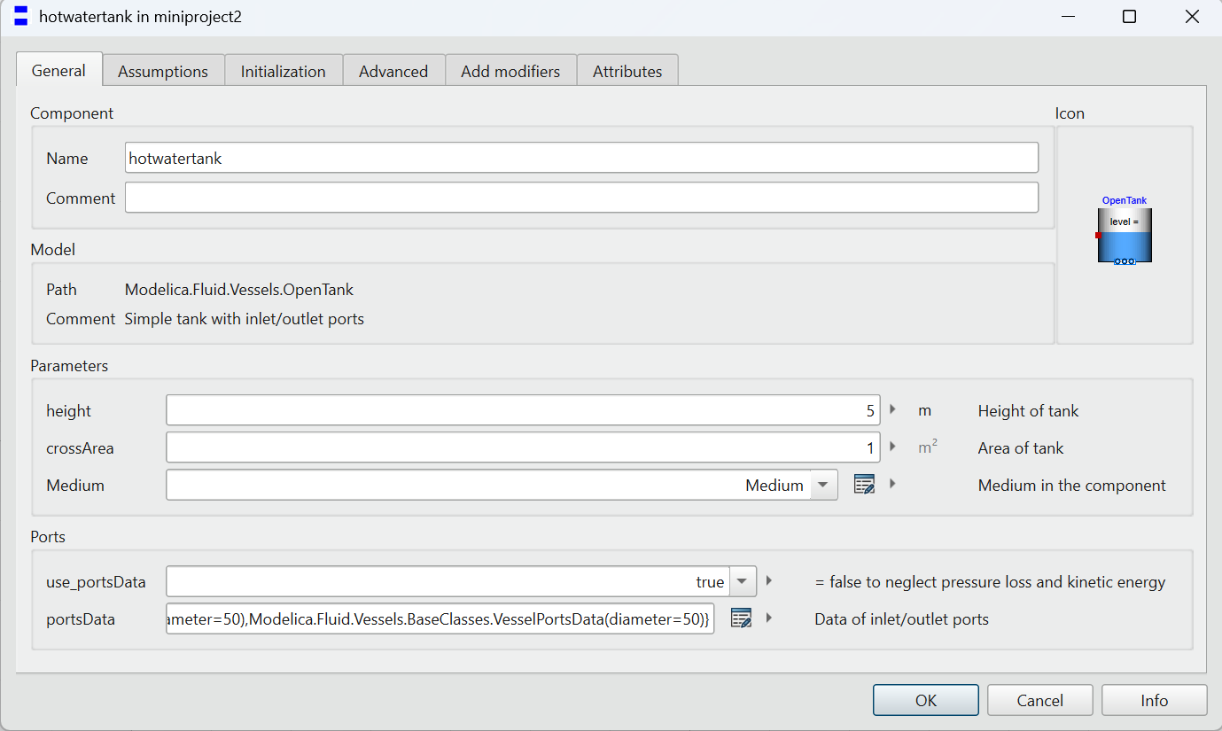
Fig. 5. Parameters of tank

As per request of the MiniProject2, this project set the maximum volume of 5 $m^{3}$.
- This project assumes that the pump will be pumping water at 4 kg/s rate when water volume in hot water tank below 0.5 $m^{3}$ (10% of the total volume), and will stop pumping water when volume is greater than 4.75 $m^{3}$(95% of the total volume).this is realized by combination of hysteresis and booleanToReal model.
- Users’ Profile
Two users’ profiles are shown in Figure 6 and Figure 7.

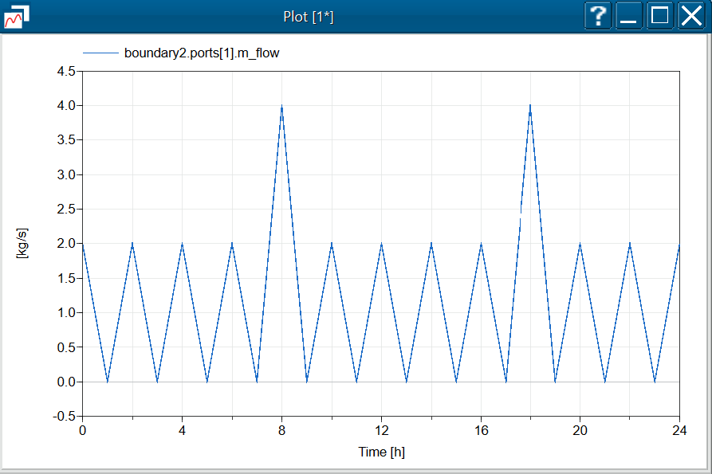
Fig. 6. Profile of user 1

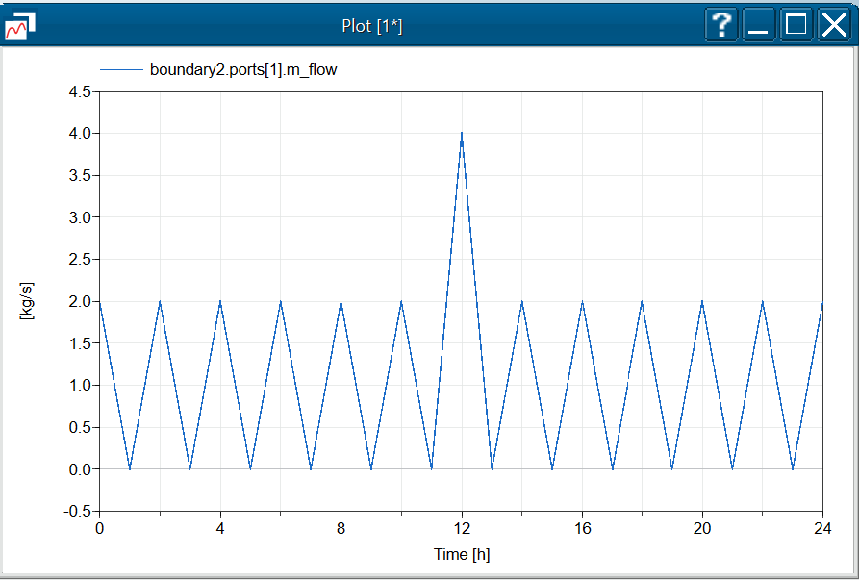
Fig. 7. Profile of user 2

These two user profiles both cover a whole day (24h). User 1’s peak load occurs in 8 AM and 6 PM, this profile is for families who may be having shower in morning and night, which takes up great deal of load. user 2’s peak load occurs in 12 AM, this profile is for families who may have to cook for their lunch. These profiles cover two kinds of typical demand of family using water.
- Simulations Results&Explanation
Based on the load curve shown in Figure 6 and Figure 7, This Project had conducted two full-day simulations of the system. In Figure 8 and Figure 9, the red line and green line shows the low limit and high limit of hysteresis, purple line shows the demand load, blue line shows water level inside the tank.
This project has found that:
As shown in Figure 8 and Figure 9, the overall water level in hot water tank can stay relatively stable between 10% and 95%. From these result graph, we can also find that when facing a load peak, it takes a little bit longer for system to raise the volume in water tank. Overall, the system still bounce back rather quick, so this system should be capable for the task demand by MiniProject 2.

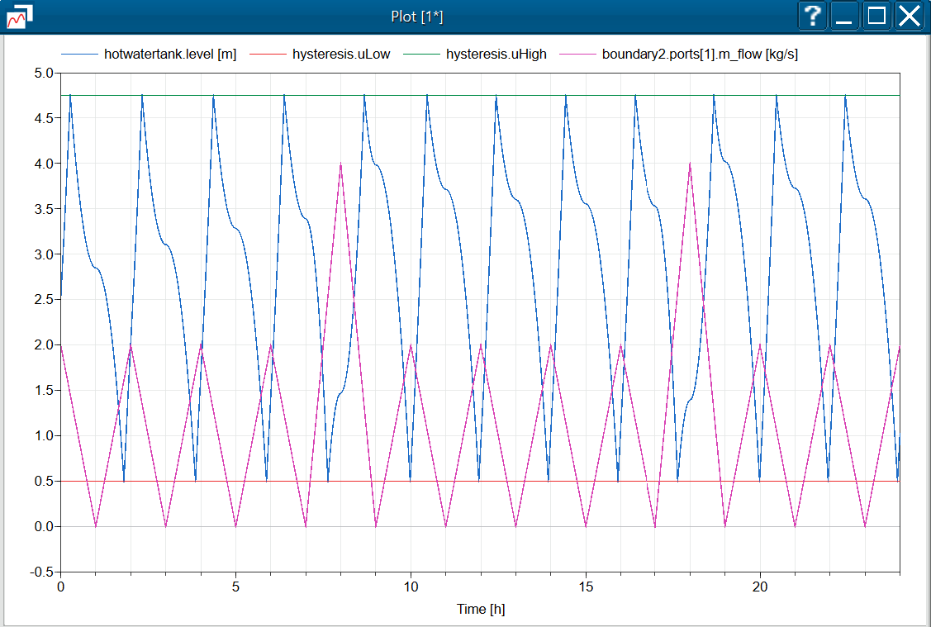
Fig. 8. Water level under load of user 1

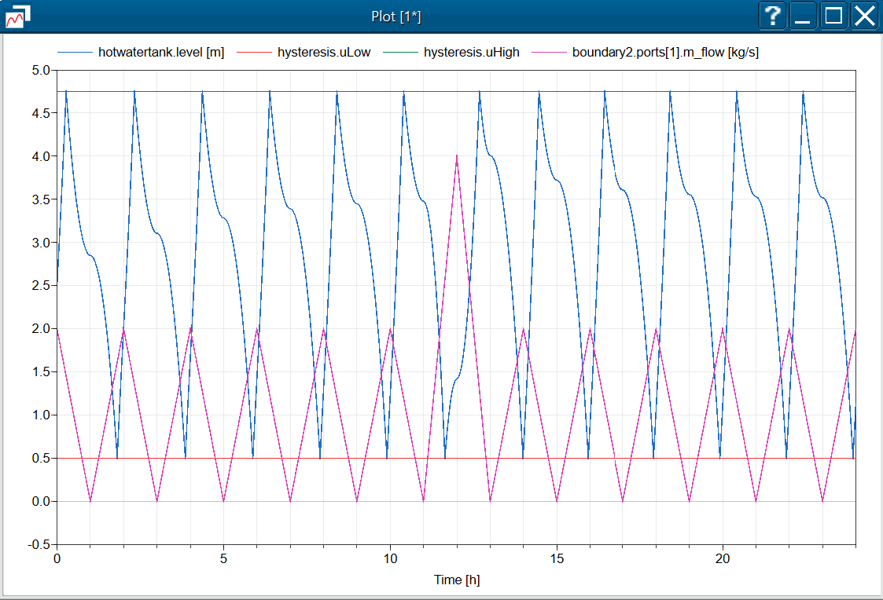

Fig. 9. Water level under load of user 2

